**DR Congo country profile**

Published

10 January 2019

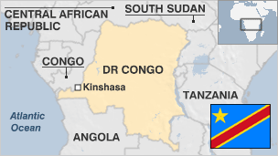

**The recent history of the Democratic Republic of Congo (DR Congo) has been one of civil war and corruption.**

DR Congo is a vast country with immense economic resources and, until recently, has been at the centre of what some observers call "Africa's world war", with widespread civilian suffering the result.

The war claimed an up to six million lives, either as a direct result of fighting or because of disease and malnutrition.

The war had an economic as well as a political side. Fighting was fuelled by the country's vast mineral wealth, with all sides taking advantage of the anarchy to plunder natural resources.

Some militias fight on in the east, where a large United Nations force is struggling to keep the peace.

* Read [more country profiles](http://news.bbc.co.uk/1/hi/country_profiles/) - Profiles by [BBC Monitoring](http://www.bbc.co.uk/monitoring)

**President (outgoing): Joseph Kabila**

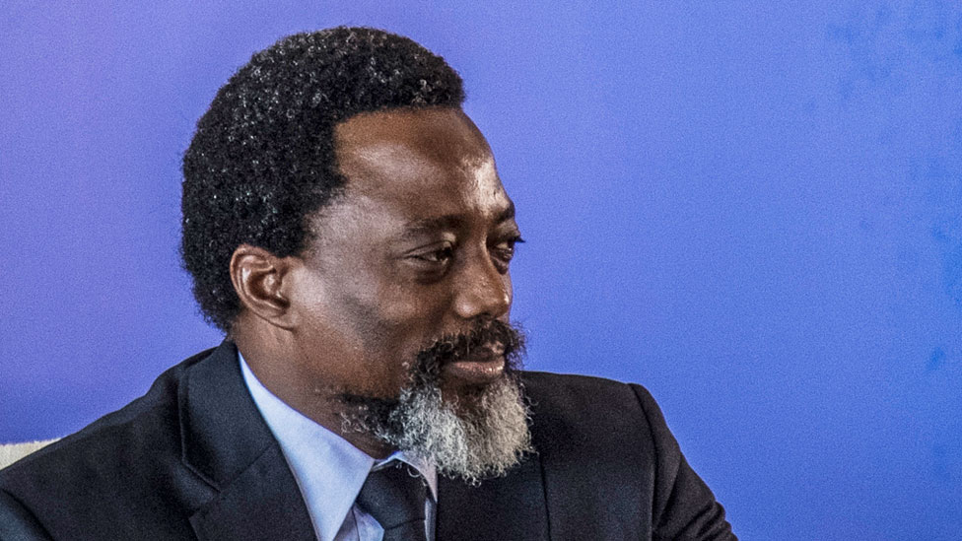image copyrightGetty Images

Joseph Kabila became president when his father Laurent was assassinated in 2001. He was elected in 2006, and secured another term in controversial elections in 2011.

He refused to leave office when his term expired in December 2016. Elections, twice delayed, were eventually held in December 2018, but the results have caused controversy. Officials declared opposition candidate Felix Tshisekedi the winner, prompting protests from rival opposition candidate Martin Fayulu of a deal with the government, whose candidate Emmanuel Ramazani Shadary came third.

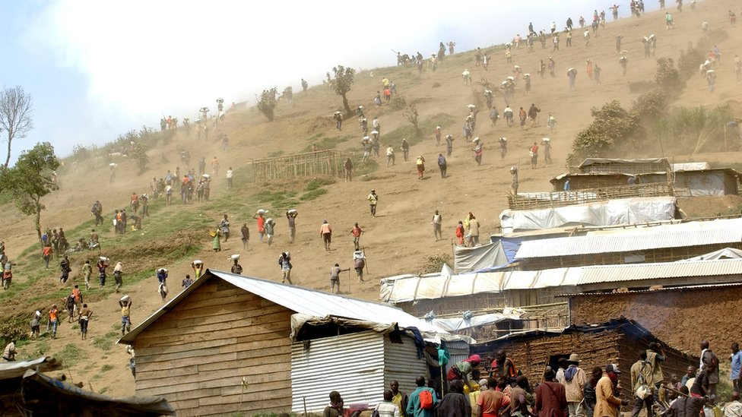image copyrightGetty Images

image captionInformal mining operations form a large part of DR Congo's minerals industry

The Congolese media operate against a backdrop of political power struggles and unrest.

Reporters Without Borders says journalists face arrest, threats and violence.

The press carries criticism of the government, and some publications reflect opposition party views.

Radio is the leading medium. Radio Okapi, partly run by the local UN mission, is an influential outlet.

# Democratic Republic of Congo profile - Timeline

Published

10 January 2019

## A chronology of key events:

**1200s** - Rise of Kongo empire, centred in modern northern Angola and including extreme western Congo and territories round lakes Kisale and Upemba in central Katanga (now Shaba).

**1482** - Portuguese navigator Diogo Cao becomes the first European to visit the Congo; Portuguese set up ties with the king of Kongo.

**16th-17th centuries** - British, Dutch, Portuguese and French merchants engage in slave trade through Kongo intermediaries.

**1870s** - Belgian King Leopold II sets up a private venture to colonise Kongo.

**1874-77** - British explorer Henry Stanley navigates Congo river to the Atlantic Ocean.

## Belgian colonisation

**1879-87** - Leopold commissions Stanley to establish the king's authority in the Congo basin.

**1884-85** - European powers at the Conference of Berlin recognise Leopold's claim to the Congo basin.

**1885** - Leopold announces the establishment of the Congo Free State, headed by himself.

**1891-92** - Belgians conquer Katanga.

**1892-94** - Eastern Congo wrested from the control of East African Arab and Swahili-speaking traders.

**1908** - Belgian state annexes Congo amid protests over killings and atrocities carried out on a mass scale by Leopold's agents.

Millions of Congolese are said to have been killed or worked to death during Leopold's control of the territory.

**1955** - Belgian Professor Antoin van Bilsen publishes a "30-Year Plan" for granting the Congo increased self-government.

**1959** - Belgium begins to lose control over events in the Congo following serious nationalist riots in Leopoldville (now Kinshasa).

## Post-independence turmoil

**1960** June - Congo becomes independent with Patrice Lumumba as prime minister and Joseph Kasavubu as president.

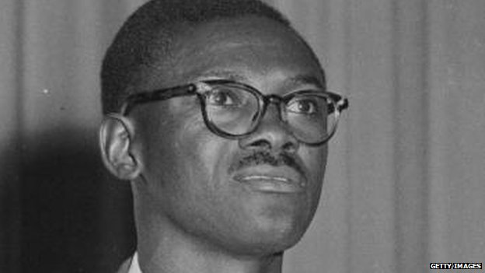image copyrightGetty Images

image captionPatrice Lumumba was independent Congo's first prime minister. He was murdered, allegedly with US and Belgian help

**1960** July - Congolese army mutinies; Moise Tshombe declares Katanga independent; Belgian troops sent in ostensibly to protect Belgian citizens and mining interests; UN Security Council votes to send in troops to help establish order, but the troops are not allowed to intervene in internal affairs.

**1960** September - President Kasavubu dismisses Mr Lumumba.

**1961** February - Patrice Lumumba murdered, reportedly with US and Belgian complicity.

**1961** August - UN troops begin disarming Katangese soldiers.

**1963** - Moise Tshombe agrees to end Katanga's secession.

**1964** - President Kasavubu appoints Mr Tshombe prime minister.

## Mobutu years

**1965** - Army chief Joseph Mobutu seizes power.

**1971** - Joseph Mobutu renames the country Zaire and himself Mobutu Sese Seko; Katanga becomes Shaba and the river Congo becomes the river Zaire.

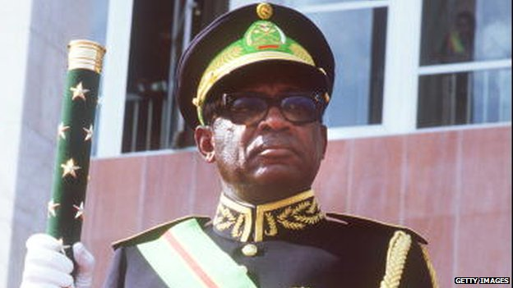image copyrightGetty Images

image captionMobutu Sese Seko renamed Congo as Zaire and looted the country during his three decades in power

**1973-74** - President Mobutu nationalises many foreign-owned firms and forces European investors out of the country.

**1977** - President Mobutu invites foreign investors back, without much success; French, Belgian and Moroccan troops help repulse attack on Katanga by Angolan-based rebels.

**1989** - Zaire defaults on loans from Belgium, resulting in a cancellation of development programmes and increased deterioration of the economy.

**1990** - President Mobutu agrees to end the ban on multiparty politics and appoints a transitional government, but retains substantial powers.

**1991** - Following riots in Kinshasa by unpaid soldiers, President Mobutu agrees to a coalition government with opposition leaders, but retains control of the security apparatus and important ministries.

**1994** - President Mobutu agrees to the appointment of Kengo Wa Dondo, an advocate of free-market reforms, as prime minister.

**1996-97** - Tutsi rebels capture much of eastern Zaire while President Mobutu is abroad for medical treatment.

## Rule of the Kabilas

**1997** May - Tutsi and other anti-Mobutu rebels, aided principally by Rwanda, capture the capital, Kinshasa; Zaire is renamed the Democratic Republic of Congo; Laurent-Desire Kabila installed as president.

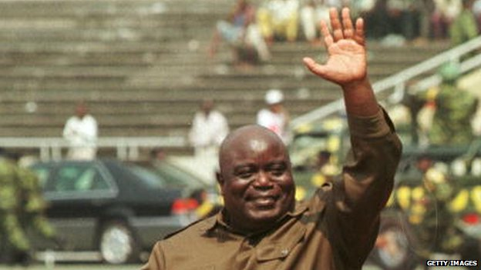image copyrightGetty Images

image captionLaurent-Desire Kabila was seen as a saviour but after a few months of peace a new war began

**1998** August - Rebels backed by Rwanda and Uganda rise up against Mr Kabila and advance on Kinshasa. Zimbabwe, Namibia send troops to repel them. Angolan troops also side with Mr Kabila. The rebels take control of much of the east of DR Congo.

**1999** July - The six African countries involved in the war sign a ceasefire accord in Lusaka. The following month the Congolese Liberation Movement (MLC) rebels supported by Uganda and Rally for Congolese Democracy (RCD) rebels backed by Rwanda also sign.

**2000** - UN Security Council authorises a 5,500-strong UN force to monitor the ceasefire but fighting continues between rebels and government forces, and between Rwandan and Ugandan forces.

**2001** January - President Laurent Kabila is shot dead by a bodyguard. Joseph Kabila succeeds his father.

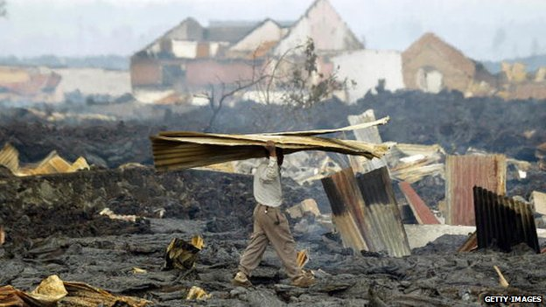image copyrightGetty Images

image captionMount Nyiragongo has erupted numerous times in living memory, and in 2002 lava from the volcano destroyed part of the nearby city of Goma

**2001** May - US refugee agency says the war has killed 2.5 million people, directly or indirectly, since August 1998.

Later, a UN panel says the warring parties are deliberately prolonging the conflict to plunder gold, diamonds, timber and coltan, used in the making of mobile phones.

**2002** January - Eruption of Mount Nyiragongo devastates much of the city of Goma.

## Search for peace

**2002** July - Presidents of DR Congo and Rwanda sign a peace deal under which Rwanda will withdraw troops from the east and DR Congo will disarm and arrest Rwandan Hutu gunmen blamed for the killing of the Tutsi minority in Rwanda's 1994 genocide.

**2002** September - Presidents of DR Congo and Uganda sign peace accord under which Ugandan troops will leave DR Congo.

**2002** December - Peace deal signed in South Africa between Kinshasa government and main rebel groups. Under the deal rebels and opposition members are to be given portfolios in an interim government.

**2003** June - French soldiers arrive in Bunia, spearheading a UN-mandated rapid-reaction force.

## Interim government

**2003** June - President Kabila names a transitional government to lead until elections in two years time. Leaders of main former rebel groups are sworn in as vice-presidents in July.

**2006** February - New constitution comes into force; new national flag is adopted.

**2006** March - Warlord Thomas Lubanga becomes first war crimes suspect to face charges at the International Criminal Court in The Hague. He is accused of forcing children into active combat.

**2006** May - Thousands are displaced in the north-east as the army and UN peacekeepers step up their drive to disarm irregular forces ahead of the elections.

## Free elections

**2006** July - Presidential and parliamentary polls are held - the first free elections in four decades.

**2006** November - Joseph Kabila is declared winner of October's run-off presidential election. The poll has the general approval of international monitors.

**2007** April - DRCongo, Rwanda and Burundi relaunch the regional Great Lakes Countries Economic Community (CEPGL).

**2007** September - Major outbreak of the deadly Ebola virus.

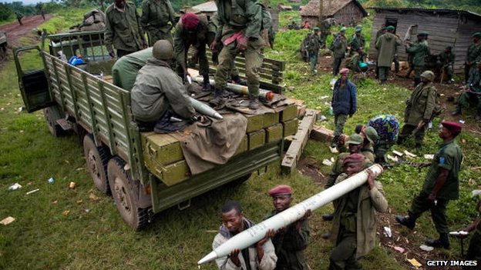image copyrightGetty Images

image captionThere has been ongoing conflict in DRCongo for decades

**2008** October - Rebel forces capture major army base of Rumangabo; the Congolese government accuses Rwanda of backing Tutsi rebel leader Laurent Nkunda, a claim Rwanda denies.

**2008** November - UN Security Council approves temporary increase of troops to bolster the strained UN peacekeeping effort in the east.

**2010** July - $8 billion debt relief deal approved by World Bank and IMF.

**2010** November - Paris Club of creditor countries scrap half of DRCongo's debt.

## Kabila re-elected

**2011** November - Presidential and parliamentary elections. Mr Kabila gains another term. The vote is criticised abroad and the opposition disputes the result.

**2013** February - Representatives of 11 African countries sign an accord in Ethiopia pledging to help end the conflict in DR Congo. The M23 rebel group declared a ceasefire ahead of the talks, and its leader Bosco Ntaganda surrenders the following month.

**2013** July - 3,000-member UN Intervention Brigade deployed to fight and disarm rebels in the east.

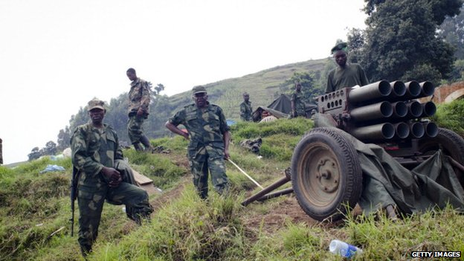image copyrightGetty Images

image captionM23 rebels have been a major fighting force in eastern DR Congo

**2015** January - Dozens killed in protests against proposed electoral law changes which the opposition said were designed to allow President Kabila to remain in power.

**2016** November - A political deal signed between President Kabila's ruling coalition and the opposition to delay the presidential election until 2018 sees Prime Minister Augustin Matata Ponyo and his cabinet resign, paving the the way for a new cabinet to include opposition figures.

**2017** December - DR Congo is experiencing a "mega-crisis", with conflict having forced 1.7 million people to flee their homes during the year, aid agencies say. DR Congo is worst-affected by conflict displacement in the world, they say.

## Controversial elections

**2018** March - Main opposition Union for Democracy and Social Progress chooses Felix Tshisekedi as its candidate for the December presidential election.

**2018** June - Government asks commissions to look at declassifying parts of Virunga and Salonga national parks, both Unesco World Heritage Sites, for oil exploration. Environmentalists claim drilling would endanger wildlife and contribute to global warming.

**2018** August - Governing People's Party for Reconstruction and Democracy chooses former interior minister Ramazani Shadary as its presidential candidate, as President Kabila cannot run for another term.

**2019** January - Officials declare opposition candidate Felix Tshisekedi the winner of December's presidential election, prompting protests from rival opposition candidate Martin Fayulu of a deal with the government, whose candidate Emmanuel Ramazani Shadary came third.